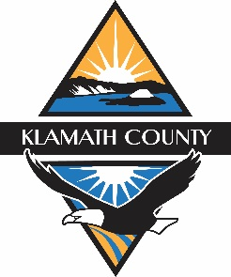
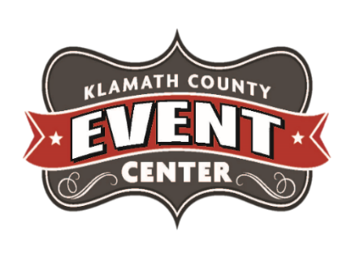
PRESS RELEASE
February 21, 2023
CHANGES, THEY ARE A COMIN’ . . .

The expansion and improvement of services offered by the Klamath County Event Center and Fairgrounds is taking another big step forward in 2023.
In 2022 Fairgoers benefitted from Phase 1 of the West Side Food Court Expansion. This expansion added more grass area for Fair attendees with a crushed granite base on which to park our many Fair food vendors, and added electrical service which eliminated the need for generators, improving the experience and reduced emissions. In 2023 you will see continued upgrades to this area with the end goal of creating an area that in addition to being a great place to enjoy food during the fair will be a place to hold weddings, flea markets, and other like events. According to Event Center Manager Derrick Rowley, these future enhancements are set to include additional restrooms, a pavilion and more green spaces.
South 6th Frontage. In 2022 the digital reader board was upgraded as a first step in refreshing the most visible side of the fairgrounds. The Keith Rice Memorial log has been deteriorating for some time. The staff is formulating a plan to dismantle the current memorial and relocate an updated memorial for Keith Rice to another section of the fairgrounds in an area where it will be more easily viewed by fairgoers. Additionally, infrastructure work will begin on the Exchange Club Park west of the Fairgrounds entrance. This will include preparations for City Water booster station and leveling of the grounds to accommodate overflow parking and future redevelopment.
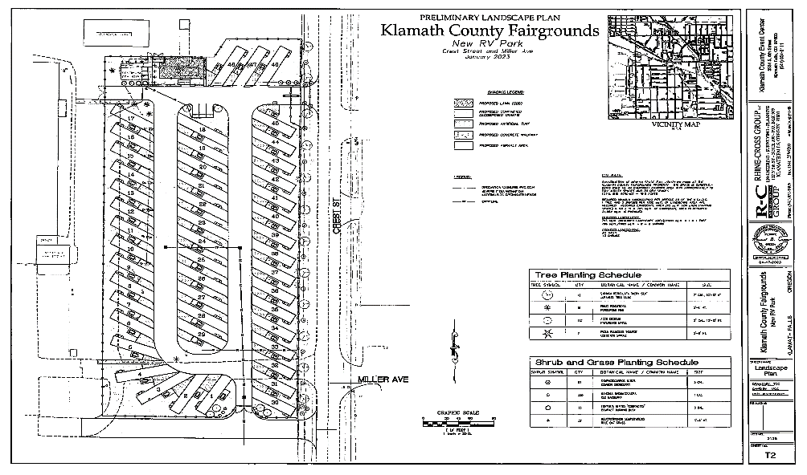
With the assistance of the South-Central Oregon Economic Development District, the Event Center/Fairgrounds is currently in the process of expanding its east RV area. A design/build contract to construct 48 full service sites is currently underway. With Rhine-Cross at the helm of this project, construction is slated to begin early April of 2023, with substantial completion scheduled for fall of 2023.This notice is being provided to you on behalf of the Klamath County Fair Board and Event Center Management.

RV Park Expansion Landscape Plan
“All of these projects stem from the work of the Fair Board and our management team to assess and meet the needs of our current and future community here in Klamath County. These projects are exciting steps to expand the experiences, resources, and opportunities that the Fairgrounds is providing to the community” said Derrick Rowley, Manager, Director of the Klamath County Event Center/Fairgrounds.

